Standard Method of Test for

Surface Resistivity Indication of Concrete’s Ability to Resist Chloride Ion Penetration

AASHTO Designation: T XXX-08

1. SCOPE

1.1. This test method covers the determination of the electrical resistivity of concrete to provide a rapid indication of its resistance to the penetration of chloride ions. This test method is applicable to types of concrete where correlations have been established between this test procedure and long-term chloride ponding procedures such as those described in ASTM C 1556. Examples of such correlations are discussed in References (15.2.).¹

1.2. The values stated in SI units are to be regarded as the standard.

1.3. This standard does not purport to address all of the safety problems, if any, associated with its use. It is the responsibility of the user of this standard to establish appropriate safety and health practices and determine the applicability of regulatory limitations prior to use.

2. REFERENCED DOCUMENTS

2.1. AASHTO Standards:
R 39, Making and Curing Concrete Test Specimens in the Laboratory
T 23, Making and Curing Concrete Test Specimens in the Field
T 24M/T 24, Obtaining and Testing Drilled Cores and Sawed Beams of Concrete

2.2. ASTM Standard:
C 670, Practice for Preparing Precision and Bias Statements for Test Methods for Construction Purposes
ASTM C 1556, Apparent Chloride Diffusion Coefficient of Cementitious Mixtures by Bulk Diffusion

3. SUMMARY OF TEST METHOD

3.1 This test method consists of measuring the resistivity of 200-mm (8-in.) or 300-mm (12-in.) nominal length and 100-mm (4-in.) or 150-mm (6-in.) nominal diameter cores or cylinders by use of a 4-pin Wenner probe array. An AC potential difference is applied in the outer pins of the Wenner array generating current flow in the concrete. The potential difference generated by this current is measured by the two inner probes. The current used and potential obtained along with the area affected are used to calculate the resistivity of the concrete. The resistivity, in Ohms-cm, has been found to be related to the resistance of the specimen to chloride ion penetration.

4. SIGNIFICANCE AND USE

4.1. This test method covers the laboratory evaluation of the electrical resistivity of concrete samples to provide a rapid indication of their resistance to chloride ion penetration. In most cases the electrical resistivity results have shown good correlation with chloride exposure tests, such as ASTM C-1556, on companion cylinders cast from the same concrete mixtures (References 15.2.).

4.2. This test method is suitable for evaluation of materials and material proportions for design purposes and research and development.

4.3. The numerical results (resistivity, in KOhm-cm) from this test method must be used with caution, especially in applications such as quality control and acceptance testing. The qualitative terms in the left-hand column of Table 1 should be used in most cases unless otherwise noted by the specifying agency.

Table 1—Chloride Ion Penetrability Based

Chloride Ion Penetrability | Surface Resistivity Test
Chloride Ion Penetrability | 100-mm X 200-mm (4 in. X 8 in.) Cylinder  (KOhm-cm)  a=1.5 | 150-mm X 300-mm  (6 in. X 12 in.) Cylinder  (KOhm-cm)  a=1.5
High | < 12 | < 9.5
Moderate | 12 - 21 | 9.5 - 16.5
Low | 21 - 37 | 16.5 – 29
Very Low | 37 - 254 | 29 – 199
Negligible | > 254 | > 199
a = Wenner probe tip spacing

4.4. The details of the test method apply to 100-mm (4 in.) and 150-mm (6 in.) nominal diameter specimens. Other specimen diameters may be tested with appropriate changes to the Wenner probe tip spacing and the correction factor in the calculating equation. (See Reference 15.3.)

4.5. Sample age may have significant effects on the test results, depending on the type of concrete and the curing procedure. Most concretes, if properly cured, become progressively and significantly less permeable with time.

Figure 1 - Four-point Wenner Array Probe Test Setup

5. INTERFERENCES

5.1. This test method can produce misleading results when calcium nitrite has been admixed into a concrete. The results from this test on some such concretes indicate lower resitivity values, that is, lower resistance to chloride ion penetration, than from tests on identical concrete mixtures (controls) without calcium nitrite. However, long-term chloride diffusion tests indicate the concretes with calcium nitrite were at least as resistant to chloride ion penetration as the control mixtures.

Note 1—Other admixtures might affect results of this test similarly. Long-term diffusion tests are recommended if an admixture effect is suspected.

5.2. Specimen curing condition is known to affect the resistivity of the solution in the pore structure (References 15.4.). Lime water curing on average reduces resistivity by 10%.

5.3. Since the test results are a function of the electrical resistance of the specimen, the presence of reinforcing steel or other embedded electrically conductive materials may have a significant effect. The test is not valid for specimens containing reinforcing.

6. APPARATUS

6.1. Surface Resistivity Apparatus: (See Figure 2 for example.) Apparatus with Wenner array probe capable of adjustment of the probe tip spacing to 38.1-mm. (1.5-in.).

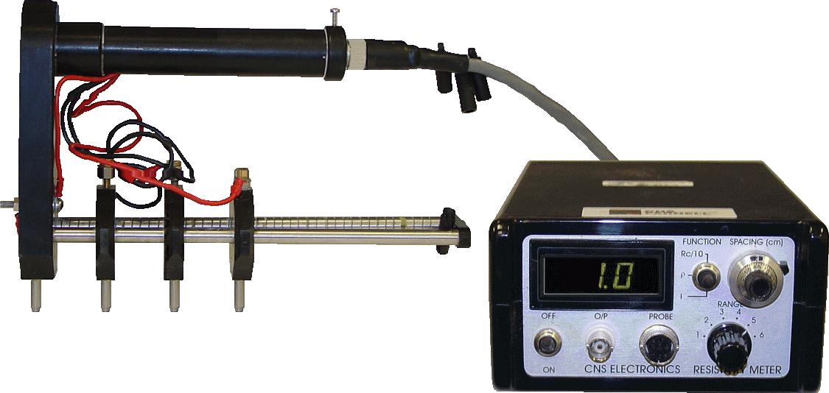

Figure 2—Surface Resistivity Apparatus

6.2. Specimen holder to prevent specimen rotation while under test. (See figure 3 for example)

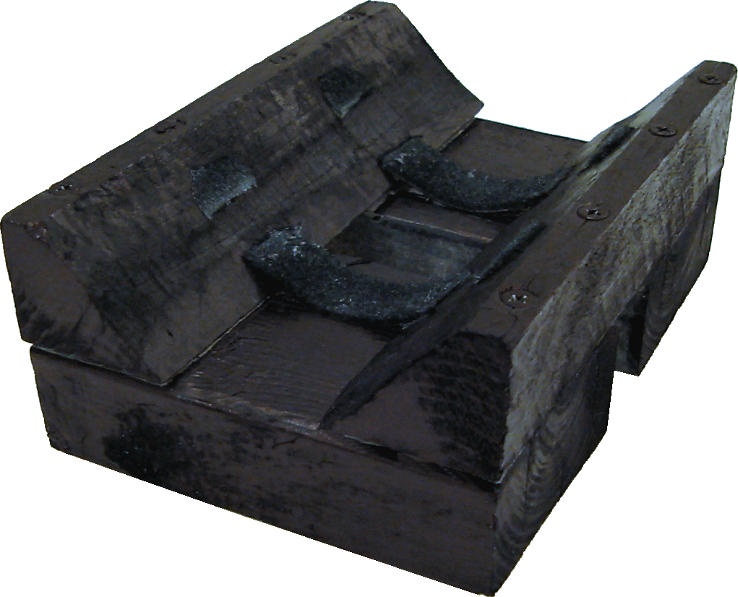
Figure 3 Specimen holder

7. REAGENTS, and MATERIALS

None

8. TEST SPECIMENS

8.1. A set is composed of a minimum of three (3) specimens samples. Sample preparation and selection depends on the purpose of the test. For evaluation of materials or their proportions, samples may be (a) cores from test slabs or from large diameter cylinders or (b) 100-mm (4-in.) diameter cast cylinders or (c) 150-mm (6-in.) diameter cast cylinders. For evaluation of structures, samples may be (a) 100-mm (4-in.) diameter cylinders cast and cured at the field site or (b) 150-mm (6-in.) diameter cylinders cast and cured at the field site. Cylinders cast in the laboratory shall be prepared following procedures in R 39. Unless specified otherwise, moist cure test specimens for 28 days prior to the start of specimen preparation (Note 3). When cylinders are cast in the field to evaluate a structure, care must be taken that the cylinders receive the same treatment as the structure, for example, similar degree of consolidation, curing, and temperature history during curing.

Note 3—This test method has been used with various test durations and curing regimens to meet agency guidelines or specifications. Care should be exercised when comparing results obtained from specimens subjected to differing conditions.

Note 4—The maximum allowable aggregate size has not been established for this test. Users have indicated that test repeatability is satisfactory on specimens from the same concrete batch for aggregates up to 37.0-mm (1.5-in.) nominal maximum size.

8.2. Transport the cores or field-cured cylinders to the laboratory in moist condition in sealed (tied) plastic bags. If specimens must be shipped, they should be packed to be properly protected from freezing and damage in transit or storage.

8.3. Special processing is necessary for core samples where the surface has been modified, for example, by texturing or by applying curing compounds, sealers, or other surface treatments, and where the intent of the test is not to include the effect of the modifications. In those cases, the modified portion of the core shall be removed.

8.4 Immediately after sample removal from the mold, make four indelible marks on the top (finish face) circular face of the specimen marking the 0, 90, 180, and 270 degree points of the circumference of the circle. Randomly assign one of the marks as o°, then counter clock wise assign the next mark 90°, and so on. Extend the marks into the longitudinal sides of the specimens. On the longitudinal sides mark the center of the longitudinal length of the specimen in order to use as a visual reference during testing. (Figure 4 for example)

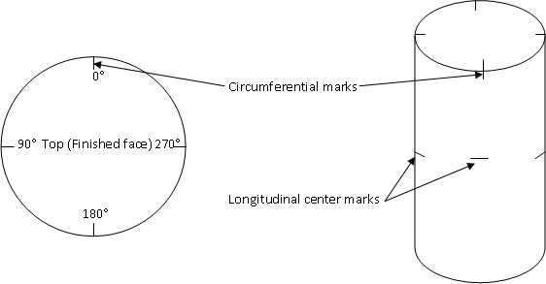
Figure 4 - Specimen marking

9. CONDITIONING

In order to saturate concrete cylinder with water, specimen must remain in a 100% humidity condition for at least 7 days prior to testing.

10. PROCEDURE

10.1. During the test, the air temperature around the specimens shall be maintained in the range of 20 to 25ºC (68 to 77ºF).

10.2. Remove specimen from water, blot off excess water, and transfer specimen to holder with the 0 degree mark on top.

10.3. Place Wenner array probe on longitudinal side on the specimen making sure longitudinal center mark is equidistant between the two inner probes. (See figure 5)

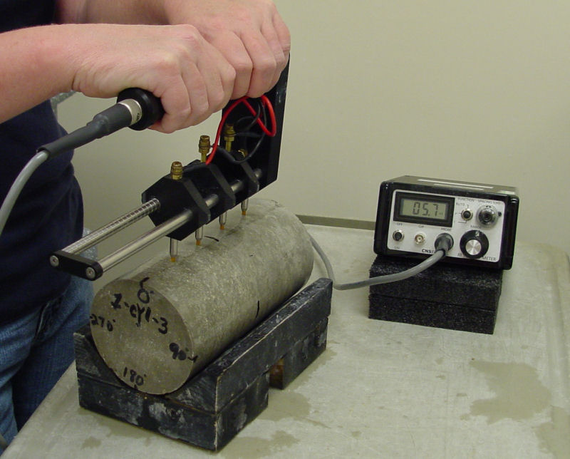
Figure 5 Wenner array placement.

10.4. Take measurement of display unit when the number becomes stable.

10.5. Rotate specimen 90° to 90 degree mark, and repeat 10.2 and 10.3 above.

10.6. Rotate specimen 90° to 180 degree mark, and repeat 10.2 and 10.3.

10.7. Rotate specimen 90° to 270 degree mark, and repeat 10.2 and 10.3.

10.8. Repeat last four readings at 0°, 90°, 180°, and 270° marks.

10.9. Repeat 10.1 to 10.8 for the other specimens in the set.

11. CALCULATION AND INTERPRETATION OF RESULTS

11.1. Calculate the average resistivity for each specimen in the set. Calculate average resitivity of the set.
Surface Resistivity (SR) Readings (Kohm-cm)
Sample | 0° | 90° | 180° | 270° | 0° | 90° | 180° | 270° | Average
A
B
C
Set Average
Curing Condition Correction (x 1.1 lime tank or 1.0 for moist room)
Penetrability Based on Test

11.2 If specimens were cured in lime water tank, multiply set average by 1.1. If specimens were cured in moist room, multiply set average by 1.0.

11.3. Use Table 1 and the size of the specimens to evaluate the test results based on the resistivity. These values were developed from data on various types of concretes.

11.3.1. Factors which are known to affect chloride ion penetration include: water-cement ratio, pozzolans, the presence of polymeric admixtures, sample age, air-void system, aggregate type, degree of consolidation, and type of curing.

12. REPORT

12.1. Report the following, if known:

12.1.1. Source of core or cylinder, in terms of the particular location the core or cylinder represents.

12.1.2. Identification number of core or cylinder and specimen.

12.1.3. Location of specimen within core or cylinder.

12.1.4. Type of concrete, including binder type, water–cement ratio, and other relevant data supplied with samples.

12.1.5. Description of specimen, including presence and location of reinforcing steel, presence and thickness of overlay, and presence and thickness of surface treatment.

12.1.6. Curing history of specimen.

12.1.7. Unusual specimen preparation, for example, removal of surface treatment.

12.1.8. Test results, reported as the surface resistivity measured, and

12.1.9. The qualitative chloride ion penetrability equivalent to the surface resistivity measured (from Table 1).

13. PRECISION AND BIAS2

13.1. Precision:

13.1.1. Single-Operator Precision—The single operator coefficient of variation of a single test result has been found to be 6.3 percent (Note 7). Therefore, the results of two properly conducted tests by the same operator on concrete samples from the same batch and of the same diameter should not differ by more than 21 percent (Note 7).

13.1.2. Multilaboratory Precision—The multilaboratory coefficient of variation of a single test result has been found to be X.X percent (Note 7). Therefore results of two properly conducted tests in different laboratories on the same material should not differ by more than XX percent (Note 7). The average of three test results in two different laboratories should not differ by more than XX percent (Note 8).

Note 7—These numbers represent, respectively, the (1s percent) and (d2s percent) limits as described in ASTM C 670. The precision statements are based on the variations in tests on three different concretes, each tested in triplicate in 11 laboratories. All specimens had the same actual diameters, but lengths varied within the range 50 ± 3 mm (2 ± 0.125 in.).

Note 8—Although the test method does not require the reporting of more than one test result, testing of replicate specimens is usually desirable. The precision statement for the averages of three results is given since laboratories frequently will run this number of specimens. When averages of three results are established in each laboratory, the multilaboratory coefficient of variation SML is calculated as:

S_{ML} = Square Root of (S²_{WL} / 3) + S²_{BL} (3)
where:
S²_{WL} = within-laboratory variance and
S²_{BL} = between-laboratory variance

The percentage cited represents the (d2s %) limit based on the value for the multilaboratory coefficient of variation.

13.2. Bias—The procedure of this test method for measuring the resistance of concrete to chloride ion penetration has no bias because the value of this resistance can be defined only in terms of a test method.

14. KEYWORDS

14.1. Chloride content; corrosion; deicing chemicals; resistance-chloride penetration.

15. REFERENCES

15.1. Chini, A.R., Muszynski, L.C., Hicks, J., "Determination of Acceptance Permeability Characteristics for Performance-Related Specifications for Portland Cement Concrete", Final Report submitted to Florida Department of Transportation (Contract No. BC 354-41)

15.2 Hamilton, H.R., Boyd, A.J., Vivas, E.A., “Permeability of Concrete – Comparison of Conductive and Diffusion Methods”, Final Report submitted to Florida Department of Transportation” (Contract No. BD536)

15.3 Morris, W., Moreno, E.I. and Sagues, A.A., "Practical Evaluation of Resistivity of Concrete in Test Cylinders using a Wenner Array Probe", Cement and Concrete Research, Vol. 26, No. 12, 1996, pp. 1779- 1787.
15.4 Kessler, R.J., Powers, R.G., and Paredes, M.A., “Resitivity Measurements of Water Saturated Concrete as an Indicator of Permeability”, Paper 05261, Corrosion 2005, NACE International.

______________________________
¹ The numbers in parentheses refer to the list of references at the end of this standard.
² Supporting data have been filed at ASTM headquarters (100 Barr Harbor Drive, Conshohocken, PA 19428-2959) and may be obtained by requesting RR: C-9-1004.

