NCHRP 20-07(281)
Peer Exchange Workshop

Overview:

An NCHRP sponsored peer exchange workshop was held as part of the AASHTO Subcommittee on Materials (SOM) Meeting in Anchorage, AK, August 2- 7, 2009. The primary purposes of this peer exchange were:
1.) to develop strategies for more efficient and effective development and maintenance of materials specifications and specifications for materials sampling and testing, and
2.) to develop strategies for funding travel expenses and proposed additional resources to assist the SOM in meeting their objectives.
The peer exchange consisted of three sessions: an overview and goals of the peer exchange at the general session on Monday August 3rd, given by Mr. Gary Hoffman. The second session was a four hour Discussion Session to answer the two concerns listed above. The final session was a report out to the full SOM on the preliminary results on Thursday afternoon.

General Session:
On Monday morning August 3rd, Gary Hoffman gave a ½ hour overview of the NCHRP 20-07 (281) Project to “set the stage” for the peer exchange. A PowerPoint presentation (Attachment 1) and survey questionnaire results with responses from 45 states (Attachment 2) were used for this overview.

Discussion Session:
The peer exchange workshop was a 4 hour session on Wednesday afternoon, August 5th, which included two plenary and two breakout sessions (two groups in each breakout). An agenda for the peer exchange along with the Powerpoint presentation are also attached (Attachment 3 and 4). SOM Chair, Grant Levi of NDDOT, gave opening remarks and charged the group with the session objectives.

Plenary Session:
Gary Hoffman, former Deputy Secretary with the PENNDOT, facilitated the first plenary session, which consisted of 37 state reps. and 15 FHWA and one NCHRP. Mr. Hoffman covered the existing SOM purpose and scope and governing regulations. He asked the group to answer two questions:
1.) what is the group’s perspective of the purpose and scope of the SOM over the next 5-7 years; and
2.) should the SOM continue to keep all 21 technical sections into which it is currently organized?

Breakout Sessions:

The participants were split into two approximately equal groups and placed in adjacent rooms. Mark Felag, RIDOT, and Tom Baker, WSDOT, facilitated these two groups and Georgine Geary, GDOT, and Bruce Yeaton, MEDOT, were scribes for the groups.

The first breakout session dealt with the production of the publications. These two directives were given to the groups:
1.) list and prioritize ways to facilitate the process of maintaining and developing specs,
2.) identify and prioritize funding options to meet needs for travel expenses and proposed additional resources.
The second breakout session dealt with how to better involve stakeholders and partners and addressed these three directives:
1.) list partners and stakeholders;
2.) list and prioritize mechanisms or opportunities to get their input to spec development and maintenance;
3.) list how to better identify research needs and implement findings.

After each breakout group completed its tasks, they were brought back together into another plenary session to compare and combine the results of their deliberations. The combined results are listed and numbered in the priority order determined by the two groups. A multi-vote was done by having each of the participants rank order their top three items in the list using colored adhesive-backed dots to vote.

Report Out
Mr. Hoffman prepared a write-up of the results of the workshop and presented them to the participants at the round table session on Thursday afternoon. A few additional comments and clarifications were received at this roundtable, and they were incorporated into the summary found below.

What should be the scope and purpose of the SOM?
- Maintain Standards
- AMRL Oversight
- Quality Assurance
- Facilitate Research
- Address National Regulations
- Identify and Promote Best Practices

Do we keep 21 technical sections?
- Tech Sections #1, 2, & 3 are needed and should be kept as is without consolidation.
- Tech Sections #4 & 5 all should continue to be addressed, but there may be areas to consider for consolidation. “Harmonization” for critical areas.

Ways to facilitate maintaining and developing specs. process (prioritized):
- Hold electronic (teleconference, webinars) meetings on a systemic basis throughout the year to make annual meeting more efficient
- Streamline development/balloting, publication process to make it fully electronic, transparent and instantaneously
- Greater use of AMRL staff in the process
- Obtain administrative assistance of a professional spec writer/editor

Identify funding options for travel and additional resources (prioritized):
- Increased funding through AASHTO mechanism (specific assessment to states, add to overall dues structure to cover expenses, pooled fund, tech service program)
- Dedicate a % of revenue from sale of red book for SCOM travel expense reimbursement
- Develop a “scholarship” program similar to NTPEP Program where industry offsets travel expense of committee meeting
- FHWA/AASHTO agreement to allow for Title 1 funds to be taken “off the top” before distribution and used to reimburse travel expenses of the subcommittee members

List of needed partners & stakeholders:
- DOTs especially at Chief Engr. level
- highway related industry Associations
- Universities (UTCs)
- local governments
- Associations
- Federal transportation agencies
- TRB/NCHRP
- toll road authorities
- testing laboratories
- test equipment manufacturers
- other AASHTO committees
- consultant community
- Associations representing the motorists (AAA , etc.)
- other specifying organizations

List mechanisms to get their input (prioritized):
- Use a systematic process to coordinate/prompt the proactive invitation by the technical section chairs of associate members, stakeholders and technical experts to membership and participation in technical committee meetings in a non-voting capacity
- Develop and promote mechanism(s) on SOM and state DOT websites to encourage input electronically from stakeholders
- Use “open” ballot process for stakeholder comment only,
- Establish active liaison with designated stakeholder groups.

How do we better identify and implement research and innovation findings?
- better interface with PAC and SCOR,
- implement ETG to “bird-dog” research needs and the development of problem statements
- hold annual webinar including stakeholders on SOM research needs prioritization
- identify “champions or lead state teams” to implement research findings, require NCHRP and SPR research to include implementation plans that put specs through AASHTO format
- use electronic notification of TC Chairs of research needs development milestones, have a process to collect and cull research needs

Attachment 1 – Presentation

Attachment 2 – Survey Results

Survey Results & Analysis
Survey: SURVEY: AASHTO Highway Subcommittee on Materials Peer Exchange
Author: mvitale@aashto.org
Filter:
Responses Received: 50
1) | Please select your member department:* (required)

Response | Count | Percent
Alabama | 1 | 2.0%
Alaska | 1 | 2.0%
Arizona | 1 | 2.0%
Arkansas | 1 | 2.0%
California | 1 | 2.0%
Colorado | 1 | 2.0%
Connecticut | 1 | 2.0%
Delaware | 1 | 2.0%
D.C. | 1 | 2.0%
Florida | 1 | 2.0%
Georgia | 1 | 2.0%
Hawaii | 0 | 0.0%
Idaho | 1 | 2.0%
Illinois | 1 | 2.0%
Indiana | 0 | 0.0%
Iowa | 1 | 2.0%
Kansas | 1 | 2.0%
Kentucky | 2 | 4.0%
Louisiana | 1 | 2.0%
Maine | 1 | 2.0%
Maryland | 1 | 2.0%
Massachusetts | 1 | 2.0%
Michigan | 1 | 2.0%
Minnesota | 1 | 2.0%
Mississippi | 1 | 2.0%
Missouri | 1 | 2.0%
Montana | 1 | 2.0%
Nebraska | 1 | 2.0%
Nevada | 1 | 2.0%
New Hampshire | 1 | 2.0%
New Jersey | 1 | 2.0%
New Mexico | 1 | 2.0%
New York | 1 | 2.0%
North Carolina | 1 | 2.0%
North Dakota | 1 | 2.0%
Ohio | 0 | 0.0%
Oklahoma | 2 | 4.0%
Oregon | 1 | 2.0%
Pennsylvania | 1 | 2.0%
Puerto Rico | 0 | 0.0%
Rhode Island | 2 | 4.0%
South Carolina | 1 | 2.0%
South Dakota | 0 | 0.0%
Tennessee | 1 | 2.0%
Texas | 1 | 2.0%
Utah | 1 | 2.0%
Vermont | 0 | 0.0%
Virginia | 1 | 2.0%
Washington | 1 | 2.0%
West Virginia | 1 | 2.0%
Wisconsin | 1 | 2.0%
Wyoming | 1 | 2.0%
Others (please specify) | 1 | 2.0%

Other Responses:
Ontario

2) | Contact Information:* (required)

Name: | Telephone:
Cecil Jones | 919 733-7411
Bryce Simons | 505/827-5191
Tom Baker | 360-709-5401
Ron Horner | 701-328-6904
Ravi V. Chandran | (860) 257-1614
Richard E. Kreider Jr. | 785 296 6618
William H. Stalcup | 573-751-1036
Luanna Cambas | 225-248-4131
Roy Capper | 304-558-9885
Reynolds Toney | 405.521.2677
Milton O. Fletcher | 803.737.6681
Steven Krebs | 608 246-7930
Bob Burnett | (518) 457-4712
Larry Lockett | 334-206-2201
Jim Pappas | 302-760-2400
Alan Rawdon | (603) 271-3151
Jim Delton | 602-712-8094
Phil Stolarski | 916-227-7254
Eileen Sheehy | 609-530-2307
Wasi Khan | 202-671-2316
Thomas O. Malerk | 352-955-6620
James Williams | 601-359-1798
Reid Kaiser | 7757204532
John F. Staton | 517-322-5701
Bill Trolinger | 615-350-4105
Curt Turgeon | 651 366 5535
Jim Zufall | 303-398-6501
George Lukes | 801-965-4859
Tom Kazmierowski | 416-242-5570
Jeff Withee | 443-572-5269
Rick Harvey | 307-777-4070
Joe Jeffrey Seiders Jr. | 512-506-5808
David Lippert | 217-782-7200
Georgene M. Geary | 404-363-7512
Allen H. Myers | 502-564-3160
jim berger | 5152391843
John Grieco | 617-951-0596
Michael C. Benson | 501-569-2185
Bruce Yeaton | 207-624-3482
Matt Strizich | 406-444-6297
Mostafa Jamshidi | 402-483-4371
R. Scott Gartin | 9072696244
Ronald Walker | 317-610-7251 x 204
Jeff Miles | 208-334-8439
Scott Seiter | 405-521-2186
William R. Bailey | 804-328-3106
Mark Felag | 401-222-2524 x-4130
Timothy L. Ramirez | 717-783-6602
Colin Franco | 401 222 3030 x4110
Cole Mullis | 503-986-3061

3) | How long have you been a member of the Subcommittee on Materials?

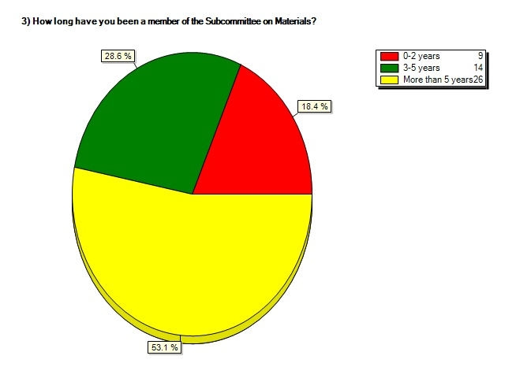

4) | How many additional years do you anticipate serving on the Subcommittee on Materials?

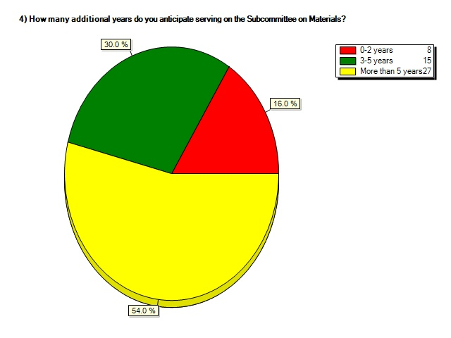

5) | How often have you attended the Subcommittee on Materials Meeting in the last 5 years?

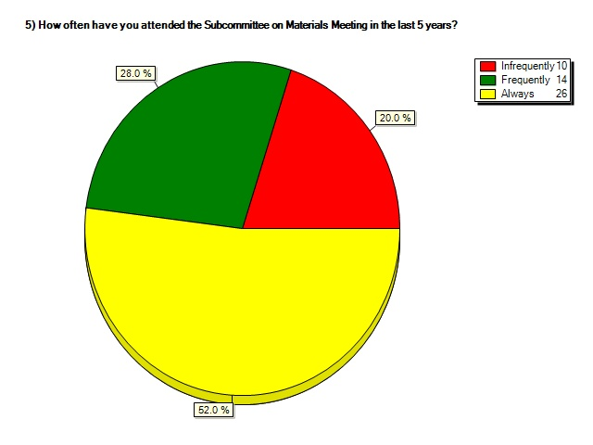

6) | Are you willing to assume a leadership role (chair or vice-chair) in the SOM technical section structure?

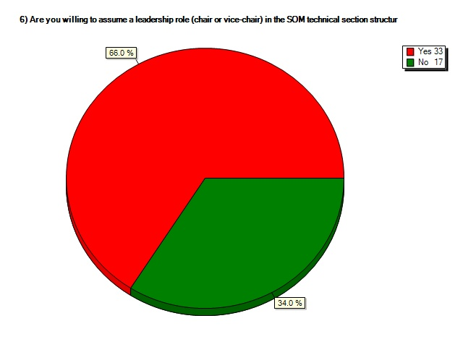

7) | If "no" to the above question, what barriers are resisting you from assuming a leadership role?

If "no" to the above question, what barriers are resisting you from assuming a leadership role?
Nearing retirement
Travel constraints imposed by the State Executive would make it difficult to assume leadership roles.
Am still too busy at daily job to do a good job in a leadership role. In a year things should be much better.
no longer the active member
I am likely to retire in approximately one year.
Travel restrictions even if funded by others.
Lake of Manpower at the present.
I am new to the Materials side of highway construction (17 years in construction) and am still learning how AASHTO operates through out the US.
The upcoming SOM meeting in Anchorage will be my first meeting. Give me a little time to get my feet wet and I will then be glad to participate a higher level.
Limited ability to travel may have an effect on future participation
Recently our travel has been severely restricted. I think to be an effective chair, one should actually attend the meetings.
Inexperience
Currently am chairing several national and international committees which require significant amounts of my time already.
additional experience with SOM operations is warranted before any consideration of a leaderhip role
I am new to MassHighway and in my current position for only 1 year. Based on goals that I have in my current position as Director (such as building a new lab)I do not know when I will have time to assume a leadership role. Maybe in 5 years from now but I do not see me able to assume leadership role before 5 years.
Not at this time. I want to attend a few more SOM meetings and become more familiar with the process before volunteering for a vice-chair or chair role.
MDT is interested in actively participating in the SOM including taking a leadership role but current staffing levels prevent us from being able to devote the necessary time.
Attendance at future SOM meetings is uncertain because of out-of-state travel restrictions.

8) | Are you involved in SOM activities beyond the annual subcommittee meetings?

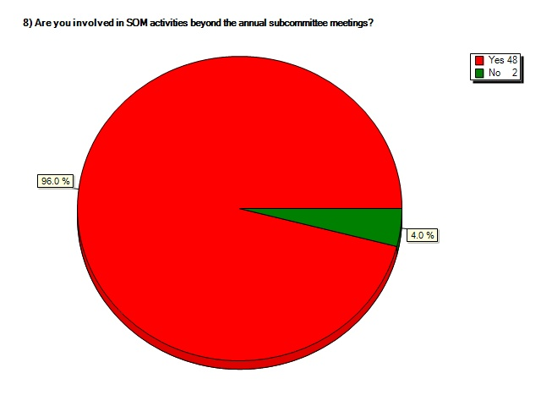

9) | If you answered "yes" to the above question, indicate how you are involved in SOM activities beyond the annual subcommittee meeting.

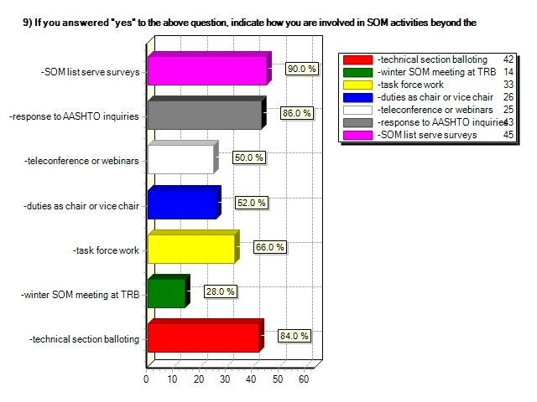

10) | In addition to your involvement with the Subcommittee on Materials , we would like to know if you are actively engaged in any other AASHTO subcommittees, panels or task forces. Please check all that apply:

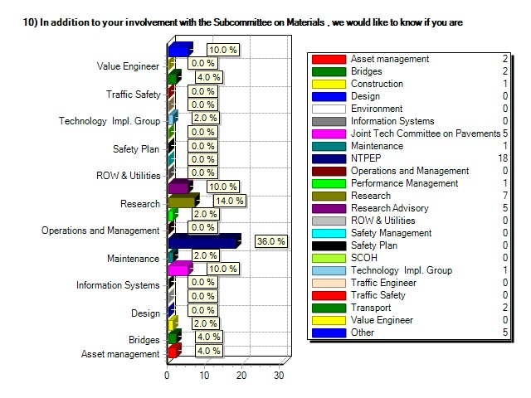
Other Responses:
NCHRP project panels for projects sponsored by SOM. Represent SOM on RAP ETG and RMRC Advisory Board
AMRL
partnering subcommittee, and project delivery subcommittee. Currently in between comittees Was part of SC on Quality
ASR AASHTO group - from FHWA's TWG
Task Force - precast concrete paving
SOM Liason to FHWA Mixture ETG
Several ETGs
My assistant is involved in NTPEP
Pavt Preservation ETG,SCOR,

11) | How often do you attend the AASHTO Board of Directors' Spring Meeting and/or Annual Conference?

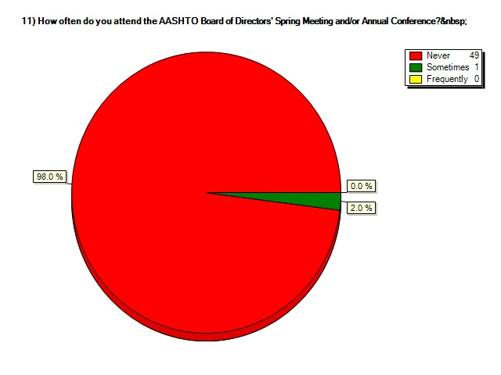

12) | Considering your agency's current policies, please indicate to what degree you are like to be able to participate in the SOM or other AASHTO meetings in the forseeable future:

Considering your agency's current policies, please indicate to what degree you are like to be able to participate in the SOM or other AASHTO meetings in the forseeable future:
Highly unlikely without financial support, and then it is not guaranteed
Minimal Participation Supported
The future is looking better than the present.
Same level as I participate now
Much depends on the ability to travel
not likely
will probably attend
See above
limited
Likely limited to one participant per SOM where we had sent two in the past.
Frequently
limited
Not this year, perhaps not next year, probably after that.
high degree--generally not limited by agency
Depends upon funding
Likely when travel fuding is furnished.
I believe ADOT will continue to participate in the SOM
very minimal
travel is extremely difficult
Most Likely
Little support to continue attendance
very involved
Good as long as my agency does not have to pay for the travel costs
Attend the annual meetings as often as possible, funding dependent.
Budget restrictions are placing very strict limits on any travel
still committed to participation
Not likely to participate in the future if meetings are in the list of banned cities and states.
Probable
Once per year, perhaps twice.
able to support core SOM business
Under travel restrictions but will probably be able to travel to locations not considered vacation destinations.
not unless travel is paid for
If in the lower 48 - and budgets recover a bit.
We have just recently set up limited training funds for this purpose
At present, the Kentucky Transportation Cabinet will allow its employees to travel out-of-state when funding is sponsored for the meeting registration and travel expenses. Funding for these expenses is not available internally within the Cabinet.
frequently
very likely
SOM and NTPEP on regular basis
Travel is currently restricted and approval to participate at future meetings is unlikely
We will likely maintain the same level of involvement.
I should be able to attend the future SOM meeting, and other meeting that AASHTO or others pay for me to attend.
Sometimes
Unless our policy on out-of-state travel is changed, future attendance to SOM meetings is doubtful.. Attendance at this year's meeting is because of AASHTO paying for the registration and trip.
at least at the same level
depends on travel restrictions, otherwise, good
SOM annual meeting
AASHTO activities are supported by our department but funding is a big concern. Unless travel is paid by others I would not be able to attend except on my own dime.
Participation and attendance to the AASHTO SOM meetings is likely to decrease. Cost reimbursement helps, but out-of-state travel is reviewed and approved on a case-by-case basis and is not always approved even if costs are reimbursed.
Participation,provided travelis paid for by others
likely

13) | Does your agency's current policy allow travel, if cost reimbursement is available?

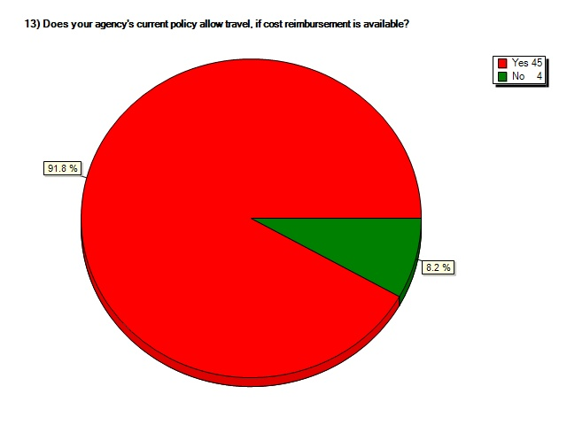

14) | Considering the issues we are facing today, do you believe that the number of Technical Sections should be reduced through prioritization or consolidation? (Should we be reducing or eliminating some of our functions?)

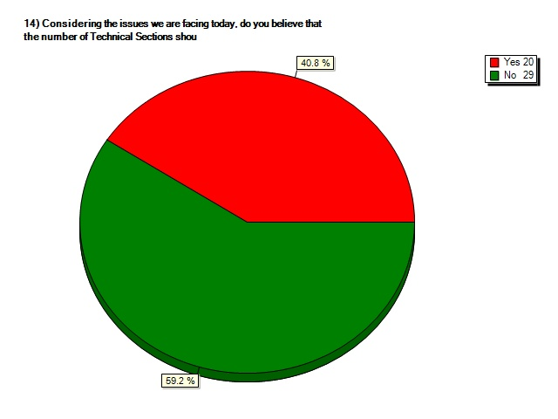

15) | Please prioritize your top ten Technical Sections from the list below given their importance to the core business of the Member Departments:

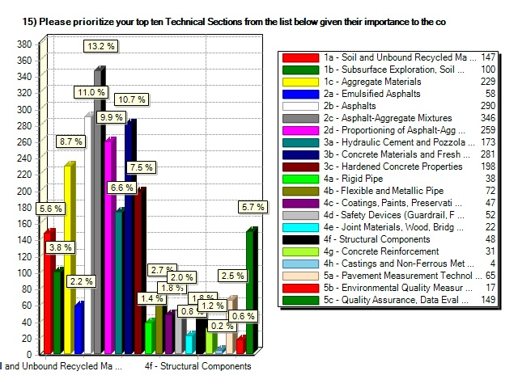

16) | Given the goal to continue the annual publication of the AASHTO Materials Book with the vital input from the SOM membership to this book, indicate one or more in priority order the possible tools or resources that can assist in accomplishing this goal over the next 5-10 years:

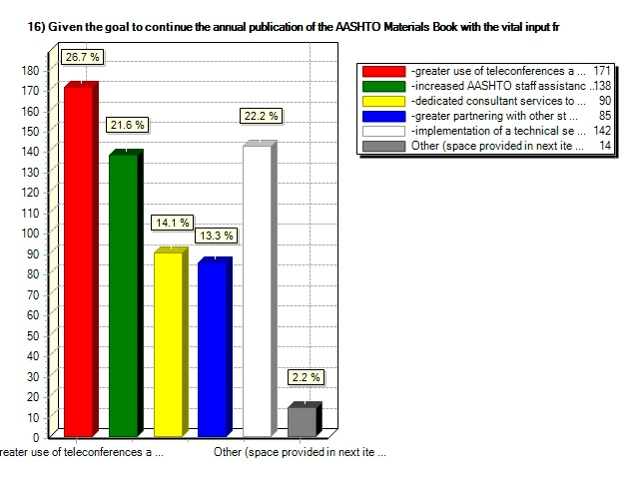

17) | If you checked "other" to the previous question, please comment below.

If you checked "other" to the previous question, please comment below.
Siphon off some of the "profit" from Red Book sales and dedicate it to the SOM for production of the Red Book.
#2 is not my favorite option, but feel it is becoming more of a consideration.
- greater involvement from industry for both standards development and updates, but no vote. Only recommendations.
Increased partnering with FHWA and industry groups. Tech Sec 2d relies heavily on the FHWA Mixture ETG for advice and standard writing and review.
Why do the books have to be reissued every year? Many standards go multiple years without reissuing books. What about a 3 year cycle for a while? That way there will not be as big of a need to expedite.
More input and recommendations to changes in standards from Expert Task Groups or similar groups with explanation and reasoning for the recommended changes. Also, AASHTO Staff or other needs to keep historical record of reasons for standard changes.

18) | If you agree with any of the list in the above question (16), what annual dollar amount fee to states would you suggest?

If you agree with any of the list in the above question (16), what annual dollar amount fee to states would you suggest?
$ 4000
As necessary. Whatever cost is required will be cheap compared to the alternative.
$3000 to $5000
10,000
$1,000.00/state
$10,000.00
$5,000 to $7,500
$5,000.00
$2500?
$10K
$6000
5000
$10,000
$5,000
State not likely to support
$2,000
5000
unknown
Approximate cost of travel, conference. amount for full reimbursement
$10,000.00
5,000
$20,000.00
$10-25K - may wish to vary by size or prorate on Fed $$
Amount needed to get the job done
$10,000
not sure
do not really agree with this thus why I have it as #5
Difficult to answer, around $5000
2500
Currently any fee would be rejected by the Administration.
10,000
don't know
$100 or a very low number
$4000-6000
$2500
$5000

19) | Since many of the updates and changes to the standard specifications for materials or methods for sampling and testing are borne out of research results or industry best practices, indicate one or more in priorty order how the SOM can best consider input and participation from the research community and industry stakeholders:

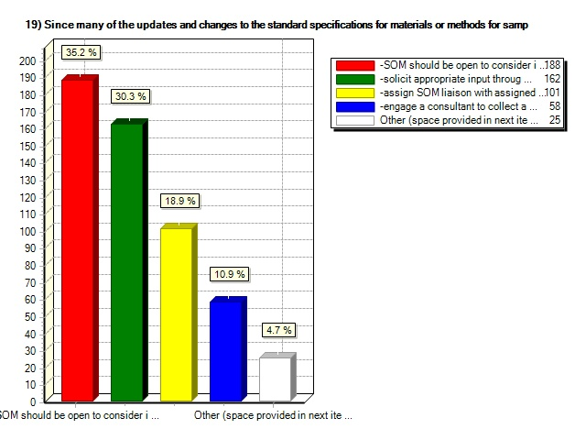

20) | If you checked "other" to the previous question, please comment below.

If you checked "other" to the previous question, please comment below.
Groups like TRB committees should have dedicated membership slots for SOM members. That way, research could be directed to practical needs and research results could be turned into new or improved standards.
Current forum for input is adequate
Need more coordination between the other SCOH Subcommittees-There may be conflict in Guides and Standards from Materials, Bridge, Construction, and Maintenance.
Partner w/ other DOT reserch programs
Research implementation pooled-fund study
If updates are not done as often than more time can be used to coordinate with academic & industry reps.
NCHRP Project Panels should liasion with SOM for important standard changes.
We should discuss this at the SOM,Research and DOT's Tests methods should be the spawning grounds for new stds

21) | What comments or recommendations regarding the SOM Peer Exchange session would you like to add that were not addressed in this survey?

What comments or recommendations regarding the SOM Peer Exchange session would you like to add that were not addressed in this survey?
An inventory of the background and skills describing above-average levels of expertise for each of the member representatives should be compiled, and provided for support of other DOT's so that more cross-over support and training can be achieved.
We could improve the web functions to aid in production of the Red Book, allowing better tracking and use of version control of standards, better control over members with built in distribution lists for each TS, etc.
I do not believe we're to a point where dramatic changes to our current process is required. However, it is always good to access where we are and where we are going.
Work toward the tech. sections having at least one other meeting, say 6 month intervals.
Have a nice meeting!
Technical experts from both academia and industry need to be encouraged to participate in the SOM meeting and in general the work of the subcommittee. We should also consider having a non-voting associate membership for technical experts. This would encourage industry and academia to take more active rolls, thereby reducing the work load of SOM members, while taking advantage of the expertise that these individuals possess. Associate members would not be allowed in excutive sessions. A specific technical session would need to approve a request for associate membership.
You should conduct this kind of survey at least once a year. Good tool to assess SOM future.
None
SOM provides a invaluable service to agency practitioners. The excellent products are a result of the knowledge and efforts of the volunteer members. Every effort should be made to encourage their continued participation at meetings and other AASHTO activities.
Question # 15 was a difficult one to answer. I do not necessarily believe that un-ranked tech sections should be eliminated. Consolidation would be more appropriate. It is understood that this will likely result in less focus on those consolidated technical areas.
This brain trust needs to be maintained and maximized.
If looking to combine sections, should consider how testing is organized in the states. For example we have one unit over all asphalt items and things that require chemical test, Bit mixtures take all HMA and other such mixes, concrete and cement are together, aggregates alone here, but could be combined with soils, metals and miscellaneous products (pipe, plastics, fabric and so on). May be best to review how several states group products with their labs and adjust Tech sections to match best you can. Only problem is you burn out the chairs - too much to keep up with. Just some quick random thoughts
We don't have the resources to keep up with all of our standards. We need to somehow reduce our standards, and use ASTM standards as much as possible. All the DOTs have to have both standards anyway. In most cases the differences between the two are very minor.
I appreciate your sponsorship of the state members to this very important meeting.
Prioritizing the Technical sections is very difficult. All sections are equally important. We need better or innovative ways to assess Quality in each and every material used in construction.
Constant reminders throughout SCOH and other executive level AASHTO committees of importance of the various Subcommittees’ and how participation is critical. Perhaps require State commitment to participate, especially if cost reimbursement provided.

Attachment 3 – Peer Exchange Agenda

Subcommittee on Materials Peer Exchange Document (7-10-09)

Time Devoted in SOM Agenda and Time Line:
Monday: 30 min (explain the process, outcome, goals)
Wednesday: 2-4 hours (12-4pm)
Timeline:
12:00 – 12:45 pm – Discussion: Role of SOM
1:00 – 2:00 pm – Small Group Discussion: Production of Publication
2:00 – 2:15 pm – Break
2:15 – 3:15 pm – Small Group Discussion: Linkage of Research
3:15 – 4:00 pm – Wrap Up

Thursday: Lunch – EC Meeting with Hoffman
Roundtable: 15 min wrap up by Hoffman

Items of Discussion
Background
        - What happened this year (loss of travel, etc)
        - How did we get here (unsuccessful proposals, successful 20-7 proposal)
      - Role of SOM (Group Discussion)
        - Mission of SOM
        - Critical Core items
        - Identification of risks to critical core items
      - Production of SOM Publications (Small Group Discussion)
        - Maintenance
        - Development
        - Partnership with other standards organizations
        - Potential models for continued production of the Red Book
          - NTPEP model
          - Others
      - Linkage of SOM with Research (Small Group Discussion)
        - Examining AASHTO standards process
        - Identify underutilized partners

Outcome/Results
Document containing the follow:
      - Outline of SOM operations and processes in the next 5-10 years allowing for the continued production of documents at a high level of quality
      - The mechanics of how AASHTO interacts with other standards setting organizations
A brief overview of the AASHTO standard development process and how outside entities (research, industry, etc) can be integrated to allow for input, feedback and participation.
Attachment 4 – Presentation

